Exp No: 5
ARDUINO BASED MANUAL ELECTRONIC COUNTER USING PROTEUS
AIM:
To write an Embedded C program for Manual Electronic counter using Arduino IDE and Proteus
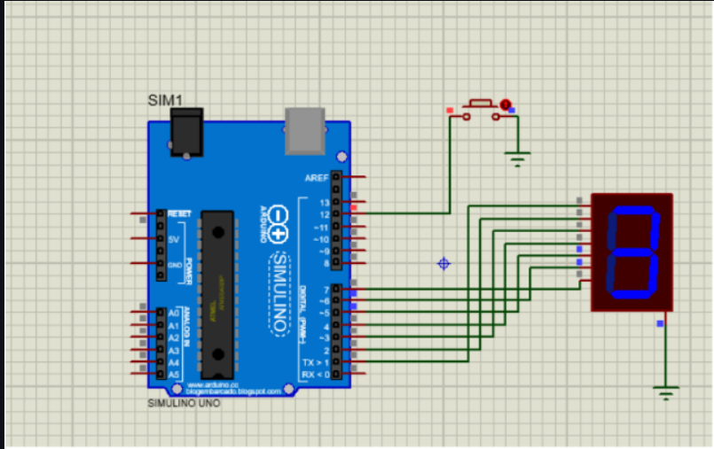

RESULT:
Thus the program has been successfully verified and executed.

